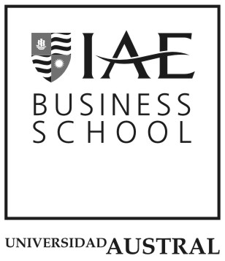
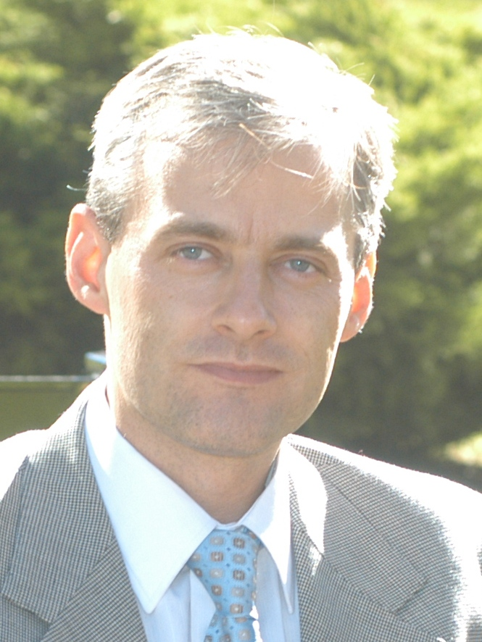
Currículum Vítae

Hector O. Rocha is Professor of Business Policy and Entrepreneurship at IAE Business School. He is PhD in Business Studies (London Business School), Master in Governance and Culture of Organizations (Navarre University), and Executive MBA (IAE Business School).
For the last 25 years, he has been devoted to identifying and realizing the positive impact entrepreneurs and managers have on the integral development of their organizations and the community where their strategies are implemented.

Transforming managerial realities to achieve sustainable integral development is the essence to his professional call. His doctoral thesis on the impact of clusters (public-private networks geographically concentrated) on development and the creation of companies won a merit prize from the European Union and his research on the impact of clusters on firm and regional development in Latin America won the Emerald-Cladea Award for the contribution of knowledge to social good. His three books on Corporate Social Responsibility and Integral Development, Entrepreneurship and the impact of clusters on regional development systematize all of these experiences and knowledge.

He shares this knowledge and experiences with internationally renowned colleagues, with whom he intensely works in collaboration. The result of his work is found in several articles published in journals and presented at international institutions such as the United Nations (UNCTAD plenary session, 2004; AOM - UN Global Compact Forum on business and development, 2006), the IADB (SME development, 1998), the OECD (2012), the Strategic Management Society (1998 – present) and the Academy of Management (2002 – present). His work is frequently quoted in journals and books.

Finally, he has worked in collaboration with companies’ managers, governments and NGOs at both the national and international level. His experience in Grupo Techint, the government of the Province of Buenos Aires and Price Waterhouse’s international consulting division before joining IAE acted as a starting point. His consulting activities with general managers and development of live cases on entrepreneurship, management and sustainable integral development, triple bottom line, mission of companies, and private-public cooperation for development are his main sources of learning and contribution.
His work with NGOs like Red Argentina de Bancos de Alimentos (Argentine Food Banks Network; founding member of the Global Food Banks Network) and Aldeas Infantiles SOS (member of Kinderdorf International SOS) is also another source of contribution and enrichment.

Hector is married to Maria Inés, with whom he dedicates family time to learning from, educating and enjoying their children Esteban, Efraín, Ignacio, José, Tobías, Miguel, María Lourdes, María Sofía, María Pilar and María Teresa.

